Stars within 50 Light Years
Every star system within 50 light years that can be seen with the naked eye (magnitude 6.5 or brighter): 132 systems, plus the Sun. The list follows the Atlas of the Universe table with the distances brought up to date from the 2007 Hipparcos reduction, and the planets brought up to date from the NASA Exoplanet Archive (11 October 2026): 20 of these systems have confirmed planets. Notes also mark the stars that move with the Ursa Major stream.
Catalog Name | RA (h m) | Dec (d m) | Galactic l | Galactic b | Classification | Visual Mag | Abs Mag | Prllx (mas) | Dist (ly) | Gliese Number | Proper Name | Notes
Sun | --- | --- | -- | -- | G2V | -26.74 | 4.83 | -- | 0.00 | -- | Sol | Has 8 planets
Alpha Centauri | 14 39.4 | -60 52 | 315.7 | -0.7 | G2V+K1V+M5.5V | -0.01 | 4.38 | 754.81 | 4.30 | Gl 559 | Rigil Kentaurus | Proxima Centauri, 0.2 ly away, has 2 planets
Alpha Canis Majoris | 06 45.1 | -16 42 | 227.2 | -8.9 | A1V+DA2 | -1.44 | 1.45 | 379.21 | 8.60 | Gl 244 | Sirius
Epsilon Eridani | 03 33.0 | -09 24 | 195.8 | -48.0 | K2V | 3.72 | 6.18 | 310.94 | 10.50 | Gl 144 |  | Has a planet
61 Cygni | 21 06.8 | +38 45 | 82.3 | -5.8 | K5V+K7V | 5.20 | 7.49 | 286.82 | 11.40 | Gl 820
Alpha Canis Minoris | 07 39.2 | +05 13 | 213.7 | +13.0 | F5IV-V+DA | 0.40 | 2.67 | 284.56 | 11.50 | Gl 280 | Procyon
Epsilon Indi | 22 03.1 | -56 48 | 336.2 | -48.0 | K4V+T1+T6 | 4.69 | 6.90 | 276.06 | 11.80 | Gl 845 |  | Has a planet
Tau Ceti | 01 44.2 | -15 55 | 173.1 | -73.4 | G8V | 3.49 | 5.68 | 273.96 | 11.90 | Gl 71 |  | Has 3 planets
Omicron² Eridani | 04 15.4 | -07 36 | 200.7 | -38.0 | K1V+DA4+M4.5V | 4.43 | 5.94 | 200.62 | 16.30 | Gl 166 | Keid
70 Ophiuchi | 18 05.3 | +02 31 | 29.9 | +11.4 | K0V+K5V | 4.03 | 5.50 | 196.72 | 16.60 | Gl 702
Alpha Aquilae | 19 50.7 | +08 50 | 47.7 | -8.9 | A7V | 0.76 | 2.21 | 194.95 | 16.70 | Gl 768 | Altair
Sigma Draconis | 19 32.1 | +69 40 | 101.3 | +21.9 | K0V | 4.67 | 5.87 | 173.77 | 18.80 | Gl 764 | Alsafi
HR5568 | 14 57.3 | -21 25 | 338.2 | +32.7 | K5V+M1V+M3V+T8 | 5.72 | 6.89 | 171.22 | 19.00 | Gl 570
36 Ophiuchi | 17 15.3 | -26 34 | 358.3 | +6.9 | K1V+K1V+K5V | 4.33 | 5.46 | 168.54 | 19.40 | Gl 663
Eta Cassiopeiae | 00 49.0 | +57 46 | 122.6 | -5.1 | G0V+K7V | 3.46 | 4.59 | 167.98 | 19.40 | Gl 34 | Achird
HIP 84478 | 17 15.9 | -26 33 | 358.4 | +6.8 | K5V | 6.33 | 7.45 | 167.49 | 19.50
HR7703 | 20 11.0 | -36 07 | 5.2 | -30.9 | K3V+M3.5V | 5.32 | 6.42 | 166.25 | 19.60 | Gl 783
82 Eridani | 03 19.8 | -43 06 | 250.8 | -56.1 | G5V | 4.26 | 5.35 | 165.47 | 19.70 | Gl 139 |  | Has 4 planets
Delta Pavonis | 20 08.5 | -66 09 | 329.8 | -32.4 | G5IV-V | 3.55 | 4.62 | 163.71 | 19.90 | Gl 780
HR8832 | 23 13.3 | +57 10 | 109.9 | -3.2 | K3V | 5.57 | 6.49 | 152.76 | 21.40 | Gl 892 |  | Has 6 planets
Xi Boötis | 14 51.2 | +19 07 | 23.1 | +61.4 | G8V+K4V | 4.54 | 5.41 | 148.98 | 21.90 | Gl 566
HR6426 | 17 18.9 | -35 02 | 351.8 | +1.4 | K3V+K5V+M2.5V | 5.91 | 6.74 | 146.29 | 22.30 | Gl 667
HR753 | 02 36.1 | +06 53 | 163.4 | -47.6 | K3V+M4.5V | 5.79 | 6.51 | 139.27 | 23.40 | Gl 105
HR222 | 00 48.4 | +05 16 | 121.5 | -57.6 | K2V | 5.74 | 6.38 | 134.14 | 24.30 | Gl 33
Beta Hydri | 00 25.4 | -77 14 | 304.8 | -39.8 | G1IV | 2.82 | 3.46 | 134.07 | 24.30 | Gl 19
107 Piscium | 01 42.6 | +20 17 | 138.9 | -41.0 | K1V | 5.24 | 5.86 | 132.76 | 24.60 | Gl 68
Mu Cassiopeiae | 01 08.5 | +54 53 | 125.4 | -7.9 | G5V+M5V | 5.17 | 5.78 | 132.38 | 24.60 | Gl 53
HR8721 | 22 56.3 | -31 35 | 15.9 | -64.6 | K4V | 6.48 | 7.07 | 131.42 | 24.80 | Gl 879 |  | TW PsA, 0.87 light years from Fomalhaut
Alpha Lyrae | 18 37.0 | +38 44 | 67.4 | +19.2 | A0V | 0.03 | 0.60 | 130.23 | 25.00 | Gl 721 | Vega | Surrounded by a ring of dust at 80AU
Alpha Piscis Austrini | 22 57.6 | -29 37 | 20.5 | -64.9 | A3V | 1.17 | 1.74 | 129.81 | 25.10 | Gl 881 | Fomalhaut
p Eridani | 01 39.7 | -56 10 | 289.6 | -59.7 | K0V+K2V | 5.76 | 6.29 | 127.84 | 25.50 | Gl 66
Chi Draconis | 18 20.5 | +72 46 | 103.5 | +28.1 | F7V+G? | 3.55 | 4.02 | 124.11 | 26.30 | Gl 713
Pi³ Orionis | 04 49.8 | +06 54 | 191.5 | -23.1 | F6V | 3.19 | 3.66 | 123.94 | 26.30 | Gl 178 | Tabit
Mu Herculis | 17 46.5 | +27 41 | 52.4 | +25.6 | G5IV+M3V+M4V | 3.42 | 3.82 | 120.33 | 27.10 | Gl 695
Beta Canum Venaticorum | 12 33.8 | +41 22 | 136.1 | +75.3 | G0V | 4.24 | 4.61 | 118.49 | 27.50 | Gl 475 | Chara
61 Virginis | 13 18.5 | -18 18 | 311.9 | +44.1 | G6V | 4.74 | 5.08 | 116.89 | 27.90 | Gl 506 |  | Has 3 planets
Zeta Tucanae | 00 20.2 | -64 54 | 308.3 | -51.9 | G0V | 4.23 | 4.56 | 116.46 | 28.00 | Gl 17
Chi¹ Orionis | 05 54.6 | +20 15 | 188.5 | -2.7 | G0V+M? | 4.39 | 4.70 | 115.43 | 28.30 | Gl 222 |  | Moves with the Ursa Major stream
HR1614 | 05 00.7 | -05 46 | 205.1 | -27.2 | K3V | 6.22 | 6.52 | 114.84 | 28.40 | Gl 183
HR6416 | 17 19.2 | -46 39 | 342.3 | -5.3 | G8V+M0V | 5.47 | 5.75 | 113.61 | 28.70 | Gl 666
HR7722 | 20 15.3 | -27 03 | 15.6 | -29.4 | K1V | 5.73 | 5.98 | 112.22 | 29.10 | Gl 785 |  | Has 2 planets
Gamma Leporis | 05 44.4 | -22 28 | 226.8 | -24.3 | F7V+K2V | 3.59 | 3.84 | 112.02 | 29.10 | Gl 216 |  | Possible Ursa Major stream member
Delta Eridani | 03 43.3 | -09 46 | 198.1 | -46.0 | K0IV | 3.52 | 3.74 | 110.61 | 29.50 | Gl 150 | Rana
HR4550 | 11 53.1 | +37 43 | 168.5 | +73.8 | G8V+M5.5V | 6.42 | 6.63 | 109.99 | 29.70 | Gl 451 |  | Groombridge 1830, High velocity star
Beta Comae Berenices | 13 11.9 | +27 53 | 43.5 | +85.4 | G0V | 4.23 | 4.43 | 109.54 | 29.80 | Gl 502
Kappa¹ Ceti | 03 19.2 | +03 22 | 178.2 | -43.1 | G5V | 4.84 | 5.04 | 109.41 | 29.80 | Gl 137
HR4523 | 11 46.5 | -40 31 | 289.8 | +20.7 | G5V+M4V | 4.89 | 5.07 | 108.45 | 30.10 | Gl 442
Gamma Pavonis | 21 26.4 | -65 20 | 328.2 | -40.3 | F7V | 4.21 | 4.38 | 107.97 | 30.20 | Gl 827
HR4458 | 11 34.6 | -32 51 | 284.8 | +27.3 | K0V+DC | 5.96 | 6.06 | 104.61 | 31.20 | Gl 432
61 Ursae Majoris | 11 41.0 | +34 13 | 183.5 | +73.3 | G8V | 5.31 | 5.40 | 104.04 | 31.30 | Gl 434
12 Ophiuchi | 16 36.4 | -02 21 | 13.7 | +28.4 | K0V | 5.77 | 5.82 | 102.55 | 31.80 | Gl 631
HR5256 | 13 57.6 | +61 29 | 109.6 | +53.9 | K3V | 6.49 | 6.48 | 99.36 | 32.80
HR511 | 01 47.9 | +63 54 | 129.1 | +1.7 | K0V | 5.63 | 5.62 | 99.33 | 32.80 | Gl 75
Alpha Mensae | 06 10.2 | -74 47 | 285.8 | -28.8 | G5V | 5.08 | 5.04 | 98.06 | 33.30 | Gl 231
HR857 | 02 52.4 | -12 48 | 192.1 | -58.3 | K1V | 6.05 | 5.97 | 96.60 | 33.80 | Gl 117
Beta Geminorum | 07 45.2 | +28 03 | 192.2 | +23.4 | K0III | 1.16 | 1.08 | 96.54 | 33.80 | Gl 286 | Pollux | Nearest giant star. Has a planet
Iota Persei | 03 09.0 | +49 36 | 144.6 | -7.4 | G0V | 4.05 | 3.94 | 94.87 | 34.40 | Gl 124
Zeta Herculis | 16 41.3 | +31 38 | 52.7 | +40.3 | G0IV+G7V | 2.81 | 2.66 | 93.32 | 35.00 | Gl 635 | Rutilicus
HR637 | 02 10.3 | -50 47 | 275.9 | -62.0 | K0V | 6.12 | 5.96 | 92.74 | 35.20 | Gl 86 |  | Has a planet
Delta Trianguli | 02 16.8 | +34 13 | 142.4 | -25.4 | G0V+M5V | 4.84 | 4.68 | 92.73 | 35.20 | Gl 92
HR9038 | 23 52.6 | +75 33 | 119.2 | +13.1 | K3V+M2V | 6.36 | 6.17 | 91.82 | 35.50 | Gl 909
Beta Virginis | 11 50.7 | +01 49 | 270.5 | +60.8 | F8V | 3.59 | 3.40 | 91.50 | 35.60 | Gl 449 | Zavijava
Beta Leonis | 11 49.0 | +14 35 | 250.6 | +70.8 | A3V | 2.14 | 1.93 | 90.91 | 35.90 | Gl 448 | Denebola
HR6806 | 18 09.6 | +38 26 | 65.3 | +24.2 | K2V | 6.38 | 6.17 | 90.71 | 36.00 | Gl 706
54 Piscium | 00 39.4 | +21 17 | 119.2 | -41.5 | K0V | 5.88 | 5.66 | 90.42 | 36.10 | Gl 27 |  | Has a planet
HIP 64797 | 13 16.9 | +17 01 | 334.4 | +78.3 | K2V | 6.49 | 6.27 | 90.32 | 36.10 |  |  | Has 2 planets
Theta Persei | 02 44.4 | +49 13 | 141.2 | -9.6 | F7V+M1V | 4.10 | 3.87 | 89.87 | 36.30 | Gl 107
Gamma Serpentis | 15 56.4 | +15 39 | 27.7 | +45.7 | F6V | 3.85 | 3.59 | 88.86 | 36.70 | Gl 603
Alpha Boötis | 14 15.7 | +19 12 | 15.1 | +69.1 | K2III | -0.05 | -0.31 | 88.83 | 36.70 | Gl 541 | Arcturus | Most luminous star within 50ly
11 Leonis Minoris | 09 35.6 | +35 48 | 188.5 | +47.8 | G8V+M5V | 5.40 | 5.12 | 87.96 | 37.10 | Gl 356
Eta Boötis | 13 54.8 | +18 23 | 5.3 | +73.0 | G0IV | 2.68 | 2.40 | 87.75 | 37.20 | Gl 534 | Muphrid
HR5553 | 14 53.6 | +19 10 | 23.6 | +60.9 | K1V | 6.00 | 5.69 | 86.88 | 37.50 | Gl 567
Zeta Doradus | 05 05.7 | -57 27 | 266.0 | -36.7 | F7V+K7V | 4.71 | 4.38 | 85.87 | 38.00 | Gl 189
Gamma Virginis | 12 41.6 | -01 28 | 297.8 | +61.3 | F0V+F0V | 2.74 | 2.40 | 85.58 | 38.10 | Gl 482 | Porrima
Iota Pegasi | 22 07.3 | +25 20 | 82.3 | -24.3 | F5V | 3.77 | 3.42 | 85.28 | 38.20 | Gl 848
Delta Capricorni | 21 47.0 | -16 07 | 37.6 | -46.0 | A5V | 2.85 | 2.48 | 84.27 | 38.70 | Gl 837 | Deneb Algedi
Zeta Reticuli | 03 18.2 | -62 32 | 279.0 | -47.2 | G1V+G2V | 5.24 | 4.84 | 83.11 | 39.20 | Gl 138
Zeta Trianguli Australis | 16 28.5 | -70 07 | 319.5 | -14.6 | F9V | 4.90 | 4.48 | 82.53 | 39.50 | Gl 624 |  | Possible Ursa Major stream member
Lambda Serpentis | 15 46.5 | +07 21 | 15.7 | +44.1 | G0V | 4.42 | 4.00 | 82.48 | 39.50 | Gl 598 |  | Has a planet
85 Pegasi | 00 02.1 | +27 06 | 109.6 | -34.5 | G3V+K6V | 5.80 | 5.37 | 82.17 | 39.70 | Gl 914
HR3384 | 08 33.0 | -31 31 | 252.3 | +5.0 | K0V | 6.38 | 5.95 | 81.91 | 39.80 | Gl 309
HR1925 | 05 41.1 | +53 27 | 158.4 | +11.9 | K1V+M1V | 6.21 | 5.76 | 81.45 | 40.00 | Gl 211
Rho¹ Cancri | 08 52.6 | +28 20 | 196.8 | +37.7 | G8V+M3.5V | 5.96 | 5.50 | 81.03 | 40.30 | Gl 324 |  | Has 5 planets
Beta Trianguli Australis | 15 54.7 | -63 26 | 321.8 | -7.5 | F2IV | 2.83 | 2.37 | 80.79 | 40.40 | Gl 601
HR3259 | 08 18.4 | -12 41 | 234.6 | +12.8 | G8V | 5.95 | 5.47 | 80.04 | 40.70 | Gl 302 |  | Has 3 planets
44 Boötis | 15 03.6 | +47 39 | 80.4 | +57.1 | G1V+G2V | 4.83 | 4.34 | 79.95 | 40.80 | Gl 575
Lambda Aurigae | 05 19.0 | +40 04 | 167.7 | +1.5 | G0V | 4.69 | 4.18 | 79.17 | 41.20 | Gl 197
HR683 | 02 19.0 | -25 58 | 214.5 | -70.4 | G8V | 6.33 | 5.82 | 78.93 | 41.30 | Gl 95
HR483 | 01 41.7 | +42 37 | 132.7 | -19.3 | G2V | 4.96 | 4.43 | 78.50 | 41.50 | Gl 67
HR4587 | 12 00.7 | -10 25 | 283.1 | +50.5 | K0IV | 5.54 | 5.01 | 78.35 | 41.60 | Gl 454
HR6094 | 16 24.0 | -39 13 | 341.6 | +7.2 | G3V+DA2 | 5.37 | 4.84 | 78.26 | 41.70 | Gl 620 |  | Has a planet
36 Ursae Majoris | 10 30.6 | +55 59 | 154.3 | +51.7 | F8V+K7V | 4.82 | 4.29 | 78.25 | 41.70 | Gl 395
HR6518 | 17 24.6 | +67 20 | 97.6 | +33.2 | K0V | 6.44 | 5.90 | 78.11 | 41.80 | Gl 675
HR6998 | 18 38.9 | -21 05 | 12.7 | -6.8 | G5V | 5.85 | 5.27 | 76.43 | 42.70 | Gl 722
Alpha Aurigae | 05 16.9 | +46 00 | 162.6 | +4.6 | G5III+G0III+M2V+M4V | 0.08 | -0.51 | 76.20 | 42.80 | Gl 194 | Capella | 2 giant stars + 2 red dwarfs 0.14ly away
58 Eridani | 04 47.7 | -16 58 | 215.4 | -34.8 | G3V | 5.49 | 4.87 | 75.32 | 43.30 | Gl 177
Theta Ursae Majoris | 09 33.1 | +51 38 | 165.5 | +45.7 | F6IV+M? | 3.17 | 2.52 | 74.19 | 44.00 | Gl 354 | Al Haud
Upsilon Andromedae | 01 36.8 | +41 22 | 132.0 | -20.7 | F8V+M4.5V | 4.10 | 3.45 | 74.12 | 44.00 | Gl 61 |  | Has 3 planets
HR8 | 00 06.7 | +29 04 | 111.3 | -32.8 | G8V | 6.07 | 5.39 | 73.15 | 44.60 | Gl 5
Beta Aquilae | 19 55.3 | +06 23 | 46.1 | -11.1 | G8IV+M3V | 3.71 | 3.03 | 73.00 | 44.70 | Gl 771 | Alshain
Iota Piscium | 23 40.1 | +05 36 | 92.5 | -53.0 | F7V | 4.13 | 3.44 | 72.92 | 44.70 | Gl 904
HR8501 | 22 18.4 | -53 38 | 339.0 | -51.4 | G1V+M? | 5.36 | 4.66 | 72.54 | 45.00 | Gl 853
18 Scorpii | 16 15.5 | -08 20 | 4.7 | +29.2 | G1V | 5.49 | 4.77 | 71.94 | 45.30 | Gl 616
10 Tauri | 03 36.7 | +00 24 | 185.1 | -41.7 | F8V | 4.29 | 3.57 | 71.62 | 45.50 | Gl 147
HR7578 | 19 54.3 | -23 55 | 17.2 | -23.9 | K3V | 6.22 | 5.48 | 71.18 | 45.80 | Gl 770
47 Ursae Majoris | 10 59.6 | +40 25 | 175.8 | +63.4 | G0V | 5.03 | 4.29 | 71.11 | 45.90 | Gl 407 |  | Has 3 planets
Gamma Cephei | 23 39.6 | +77 37 | 119.0 | +15.3 | K1IV+M? | 3.21 | 2.46 | 70.91 | 46.00 | Gl 903 | Errai | Has a planet
26 Draconis | 17 34.6 | +61 53 | 91.0 | +32.7 | G1V+K3V+M1V | 5.23 | 4.47 | 70.47 | 46.30 | Gl 684
Tau¹ Eridani | 02 45.2 | -18 33 | 200.8 | -62.5 | F6V | 4.47 | 3.71 | 70.32 | 46.40 | Gl 111
Alpha Fornacis | 03 12.2 | -28 58 | 224.7 | -59.0 | F7IV+G7V | 3.80 | 3.03 | 70.24 | 46.40 | Gl 127 | Fornacis
Eta Cephei | 20 45.7 | +61 50 | 97.9 | +11.6 | K0IV | 3.41 | 2.64 | 70.10 | 46.50 | Gl 807
72 Herculis | 17 20.7 | +32 30 | 55.9 | +32.3 | G1V | 5.38 | 4.60 | 69.80 | 46.70 | Gl 672
Pi¹ Ursae Majoris | 08 39.1 | +64 59 | 150.6 | +35.7 | G1V | 5.63 | 4.84 | 69.66 | 46.80 | Gl 311 |  | Possible Ursa Major stream member
HR7898 | 20 40.3 | -23 45 | 21.3 | -33.8 | G8V | 6.36 | 5.57 | 69.53 | 46.90 | Gl 796 |  | 1.68ly from Psi Capricorni
111 Tauri | 05 24.4 | +17 23 | 187.2 | -10.3 | F8V+K4V+K5V | 5.00 | 4.21 | 69.51 | 46.90 | Gl 202
Iota Ursae Majoris | 08 59.0 | +48 03 | 171.5 | +40.8 | A7V+M1V+M? | 3.12 | 2.31 | 68.92 | 47.30 | Gl 331 | Talita
Theta Boötis | 14 25.1 | +51 48 | 93.8 | +59.7 | F7V+M3V | 4.04 | 3.23 | 68.82 | 47.40 | Gl 549 | Asellus Primus
Psi Serpentis | 15 43.9 | +02 32 | 9.7 | +42.0 | G5V+M? | 5.86 | 5.03 | 68.22 | 47.80 | Gl 596.1
Psi Capricorni | 20 46.1 | -25 16 | 20.0 | -35.5 | F5V | 4.13 | 3.30 | 68.13 | 47.90 | Gl 805
Nu² Lupi | 15 21.8 | -48 17 | 327.1 | +7.4 | G2V | 5.65 | 4.80 | 67.51 | 48.30 | Gl 582 |  | Has 3 planets
HR7162 | 18 56.8 | +32 52 | 63.3 | +13.3 | G0V+K1V | 5.20 | 4.34 | 67.24 | 48.50 | Gl 738
Eta Leporis | 05 56.4 | -14 13 | 219.8 | -18.5 | F0V | 3.71 | 2.85 | 67.21 | 48.50 | Gl 225
Alpha Ophiuchi | 17 34.8 | +12 35 | 35.9 | +22.6 | A5III-IV | 2.08 | 1.21 | 67.13 | 48.60 | Gl 681 | Rasalhague | Possible Ursa Major stream member
Alpha Corvi | 12 08.5 | -24 45 | 290.7 | +37.1 | F2V | 4.02 | 3.15 | 66.95 | 48.70 | Gl 455.3 | Alchibah
I Hydrae | 09 42.2 | -23 56 | 256.7 | +21.5 | G0V | 4.93 | 4.05 | 66.61 | 49.00 | Gl 364
Alpha Cephei | 21 18.4 | +62 36 | 101.0 | +9.2 | A7IV-V | 2.45 | 1.56 | 66.50 | 49.00 | Gl 826 | Alderamin
20 Leonis Minoris | 10 01.2 | +31 56 | 195.0 | +52.9 | G2V | 5.37 | 4.48 | 66.46 | 49.10 | Gl 376 |  | Has a planet
Nu Phoenicis | 01 15.1 | -45 32 | 290.1 | -71.0 | F8V | 4.97 | 4.07 | 66.16 | 49.30 | Gl 55
HR209 | 00 45.7 | -47 36 | 305.7 | -69.5 | G5V | 5.80 | 4.90 | 65.97 | 49.40 | GJ 1021
HIP 27435 | 05 48.8 | -04 06 | 209.4 | -15.8 | G4V | 5.97 | 5.06 | 65.89 | 49.50
31 Aquilae | 19 25.1 | +11 57 | 47.4 | -1.9 | G8IV | 5.17 | 4.26 | 65.89 | 49.50 | Gl 759
HR3018 | 07 45.6 | -34 10 | 249.1 | -4.8 | G0V+DC | 5.36 | 4.45 | 65.75 | 49.60 | Gl 288
19 Draconis | 16 55.6 | +65 09 | 95.7 | +36.5 | F6V | 4.88 | 3.96 | 65.54 | 49.80 | Gl 648
Column 1: Bayer/Flamsteed designation, or the star’s number in the Harvard Revised Bright Star Catalogue (HR). Columns 2–3: right ascension (hours, minutes) and declination (degrees, minutes), epoch 2000. Columns 4–5: galactic longitude and latitude. Column 6: spectral class of the stars in the system. Column 7: apparent visual magnitude. Column 8: absolute magnitude (the magnitude at 32.6 light years). Column 9: parallax in milliarcseconds. Column 10: distance in light years (= 3261.56 / parallax). Column 11: number in the Gliese Catalogue of Nearby Stars. Column 12: proper name. Column 13: notes.
On the Atlas list but now measured just beyond 50 light years: Xi Ursae Majoris, HR5864, Mu Arae.

Maps
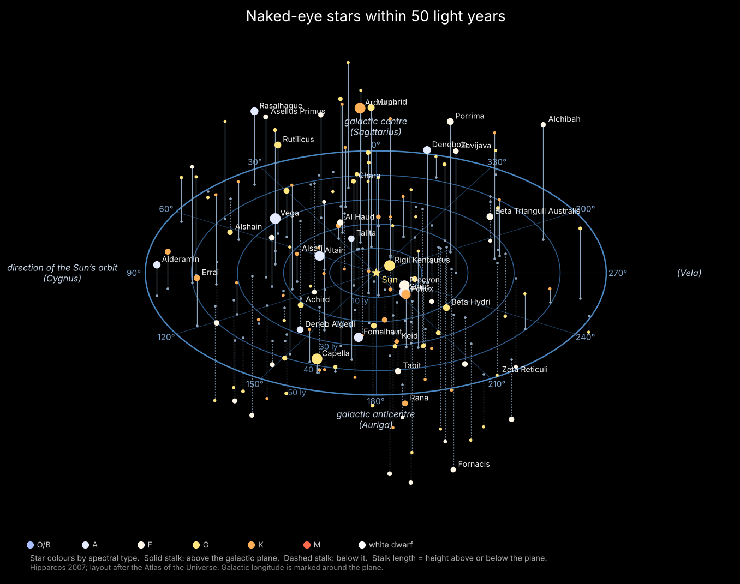
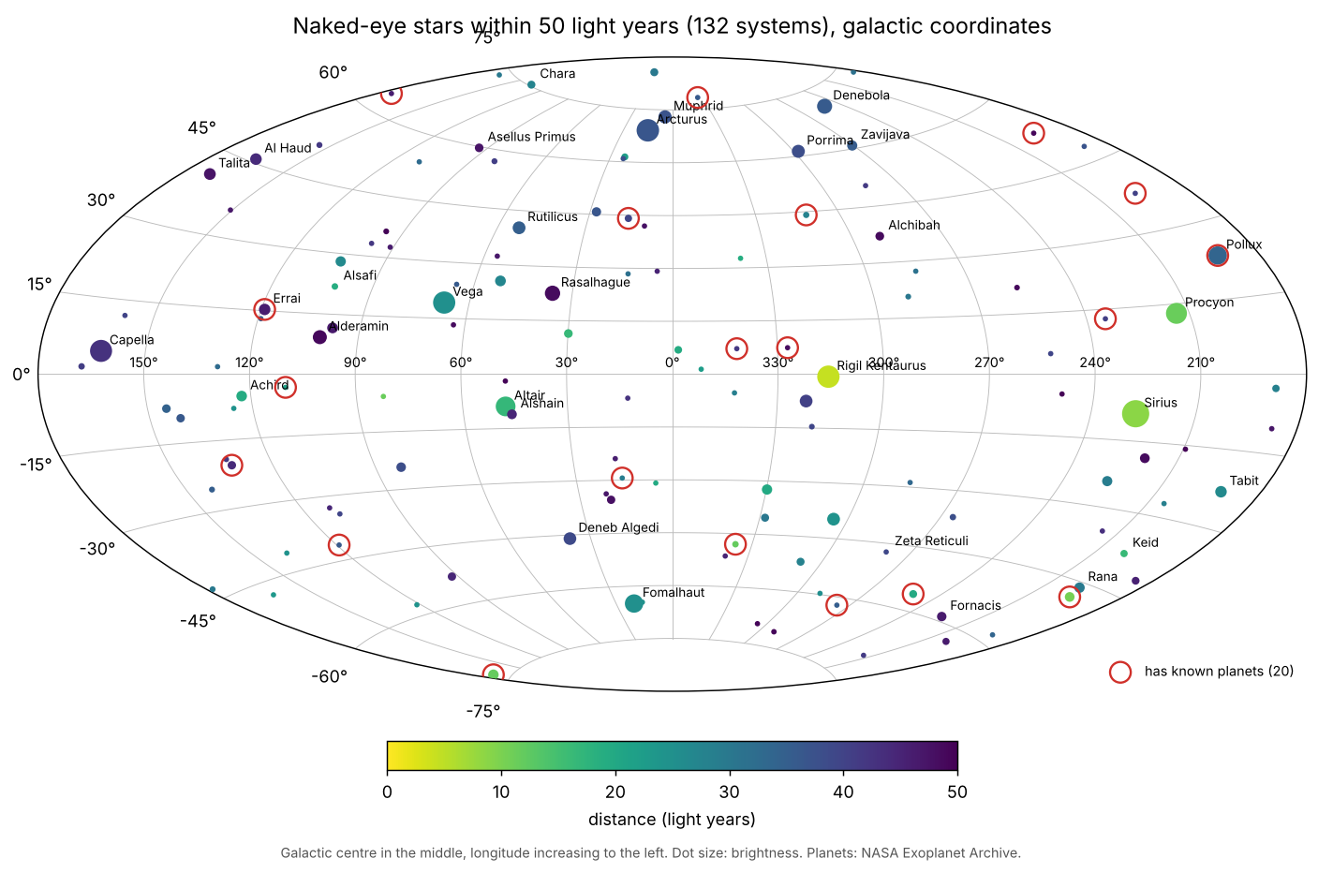
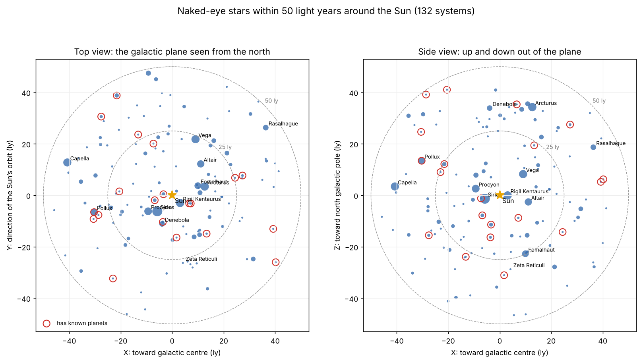
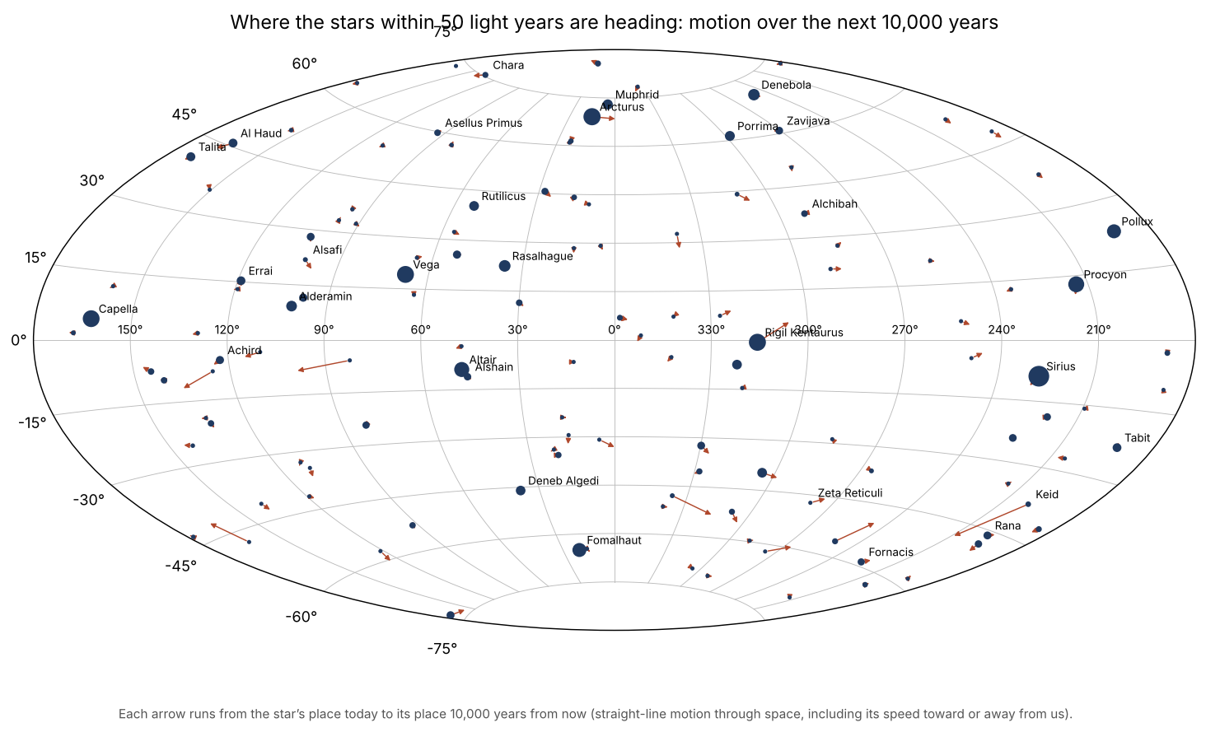

Sources
- van Leeuwen F. (2007), Hipparcos, the New Reduction of the Raw Data (parallaxes, proper motions), VizieR I/311.
- ESA (1997), The Hipparcos and Tycho Catalogues (magnitudes, spectral types), VizieR I/239.
- Kostjuk N.D. (2002), HD-DM-GC-HR-HIP-Bayer-Flamsteed Cross Index, VizieR IV/27A.
- Gaia Collaboration (2023), Gaia Data Release 3 (stars too faint for Hipparcos), ESA Gaia Archive.
- Gontcharov G.A. (2006), Pulkovo Compilation of Radial Velocities for 35,495 Hipparcos stars, VizieR III/252.
- NASA Exoplanet Archive, Planetary Systems Composite Parameters, exoplanetarchive.ipac.caltech.edu, accessed 11 October 2026.
- Gliese W., Jahreiß H. (1991), Third Catalogue of Nearby Stars; Hoffleit D., Warren W. (1991), Bright Star Catalogue, 5th ed.
- King J.R. et al. (2003), Stellar Kinematic Groups II: the Ursa Major Group, Astronomical Journal 125, 1980.
- Powell R., An Atlas of the Universe, “Stars within 50 light years” (atlasoftheuniverse.com): layout, Gliese numbers, combined spectral classes and notes.

